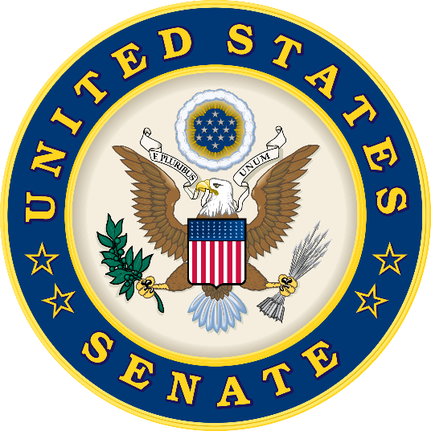
FACT versus FICTION
Bipartisan regulatory relief helps Main Street and rural communities while staying tough on Wall Street

CLAIM: This bill would gut Wall Street Reform, which was passed after the financial crisis to prevent another global meltdown.
REALITY: This bipartisan bill makes targeted, commonsense fixes that will provide tangible relief to community banks and credit unions, while leaving in place the rules and regulations that keep Wall Street accountable. Congressman Barney Frank, one of the authors of Dodd-Frank, has written that if this “bill became law tomorrow, well over 90 percent of the Wall Street Reform bill would be unchanged. The Consumer Financial Protection Bureau; the strict regulation of derivative trading; the orderly liquidation authority; the risk retention requirements on securitizations and most other provisions would remain in full force. There would be no change at all in the law as it applies to J.P.Morgan Chase; Bank of America; Wells Fargo; Morgan Stanley; Citicorp; or Goldman Sachs.” Additionally, Frank has written: “it would be wholly inaccurate to accuse them of undermining the basic regulatory regime adopted in 2010.”

CLAIM: This bill rolls back stress testing requirements for all big banks. Without effective, annual stress tests, taxpayers could once again be on the hook when ‘too big to fail’ banks collapse.
REALITY: This bill ensures that all banks over $100 billion—the 38 largest institutions—will continue to be subject to rigorous stress testing “to evaluate whether such bank holding companies have the capital, on a total consolidated basis, necessary to absorb losses as a result of adverse economic conditions,” as was required in Dodd Frank. Jay Powell, at his confirmation hearing, called the framework in this bill “a sensible one,” and he affirmed that he would like to continue “meaningful” stress tests on banks between $100 billion and $250 billion, as provided for in this bill, while confirming that it isn’t necessary to stress test smaller banks. That’s a position in line with that of current Fed Chair Janet Yellen, who recently voiced support for the Senate effort, telling the Joint Economic Committee in congressional testimony that “I do think it’s appropriate to tailor regulations to the system footprint of the financial organization,” and calling the bipartisan Senate bill “a move in a direction that we think would be good.”

CLAIM: This bill would allow dozens of the largest banks to once again borrow more money than they can afford to lose by weakening enhanced capital requirements.
REALITY: The bipartisan bill does not modify the capital or Comprehensive Capital Analysis and Review (CCAR) requirements imposed by the Fed on large banks, and the bill does not make any changes to narrow which banks are subject to the requirements.

CLAIM: This bill would gut oversight of foreign megabanks operating in the U.S., such as Deutsche Bank, Barclay’s, and Credit Suisse, which have repeatedly violated U.S. laws.
REALITY: Deutsche Bank, Barclay’s and Credit Suisse will still be subject to Section 165 of Dodd Frank. This means that foreign banks will still be subject to the foreign bank stress test requirement, liquidity stress testing, and strict Basel III capital requirements. And this bipartisan bill does not change the Fed’s requirement that large foreign banks establish an intermediate holding company in the U.S., which subjects a foreign bank’s U.S. operations to requirements similar to those imposed on U.S. banks.

CLAIM: This bill would exempt dozens of the largest banks from making “living wills” to make sure that if a bank fails, it won’t bring the entire economy down.
REALITY: Banks that the Fed has labeled “systemically important” will continue to make living wills. This bipartisan bill provides the Fed with the ability to tailor living will requirements for banks between $100 billion and $250 billion that have not been termed “systemically important.”

CLAIM: This bill blocks some homeowners from going to court to stop banks from wrongfully foreclosing and kicking them out of their homes.
REALITY: Under this bipartisan bill, borrowers can still sue any lender that has committed fraud or illegal acts.

CLAIM: This bill does nothing to protect consumers.
REALITY: This bipartisan bill will ensure that small lenders can provide mortgage and other credit to hardworking Americans, helping them and their families grow and start businesses. The bill also institutes several important consumer protections, including: one free year of fraud alerts for consumers impacted by the Wells Fargo scandal and the Equifax breach; unlimited free credit freezes and unfreezes; prevents credit bureaus from placing negative information on veterans' credit scores for one year due to mix-ups in Choice Program payments; prevents mortgage companies from immediately kicking tenants out of their rentals if the landlord is foreclosed upon; encourages banks to report suspicious behavior if seniors could be getting financially scammed; and allows seriously delinquent private student loan borrowers a one-time offer to remove negative reporting from their credit reports after making a series of on-time payments.

From the offices of
U.S. Senator Joe Donnelly (D-IN)
U.S. Senator Heidi Heitkamp (D-ND)
U.S. Senator Jon Tester (D-MT)
U.S. Senator Mark Warner (D-VA)

